Aim:

The aim of this experiment is to investigate the pn-junction diodes. To learn more about their i-v characteristics

Experimental Work:

- A good diode will produce a voltage between 0,500 to 0,900 for silicon diode, if forward current flow is established.

In reversed bias, if the diode is good, “1”
Will be displayed. “1” means overrange.

 | Forward Biased | Reversed Biased
Vdiode | 0,6775 V | Overranged

From this table we can see that our diode is good.

- At this part we setuped the circuit , and increased the voltage on the power supply until the voltage across the diode is wanted value.Then we investigated the v-i characteristics of diode.

Diode Volts | Current in mA
.35 | 0,0026 mA
.40 | 0,0079 mA
.45 | 0,0259 mA
.50 | 0,0690 mA
.55 | 0,1956 mA
.60 | 0,5710 mA
.65 | 1,663 mA
.70 | 4,498 mA
.75 | 10,954 mA
.80 | 24,31 mA
.85 | 48,11 mA
.90 | 79,60 mA

-1-
- In this part we calculated the bulk resistance of diode. First we measured the Vf value at 40 mA and 50 mA. Then use the formula to find r

Silicon Diode 1N4148
I | V | r
40mA | 0,835V | 1,8  ohm
50mA | 0,853V | 1,8  ohm

- In this part we setuped the circuit in part 2, but changed the R value. New R value was 1Mohm. We measured the resistor voltages and calculated the diode current.

Source  Voltage | Silicon Diode 1N4148
Source  Voltage | V resistor(measured) | Idiode(calculated)
0 | -0,0025 V | 0.100 x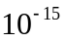 A
-1 | 2,59 mV | -A
-2 | 2,87 mV | -A
-3 | 2,94 mV | -A
-4 | 3,15 mV | -A
-5 | 3,29 mV | -A
-10 | 3,68 mV | -A
-15 | 4,03 mV | -A
-20 | 4,34 mV | -A
-25 | 4,52 mV | -A

Calculation:

-2-

6)

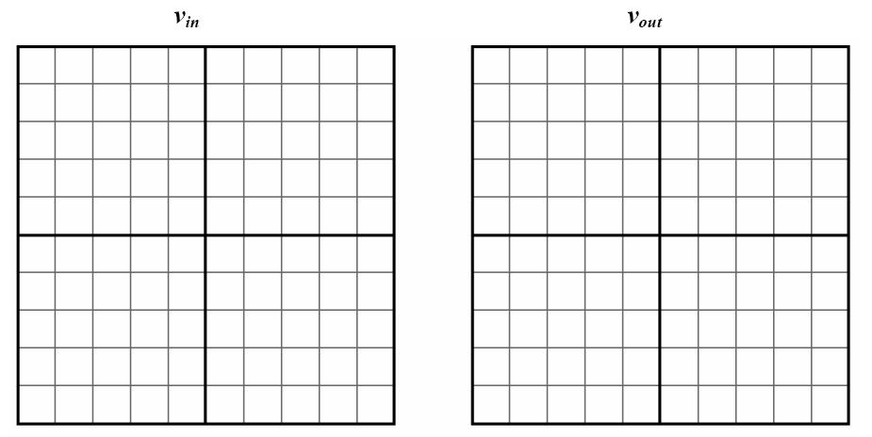

-3-

